**Math 155, *Lecture Notes- Bonds* Name____________**

***Section 10.1*** *Conics and Calculus*

In this section, we will study conic sections from a few different perspectives. We will consider the geometry-based idea that conics come from intersecting a plane with a double-napped cone, the algebra-based idea that conics come from the general second-degree equation in two variables, and a third approached based on the concept of a **locus** (collection) of points that satisfy a certain geometric property

*Three Standard Conics (a circle is a special ellipse) and Three Degenerate Forms*

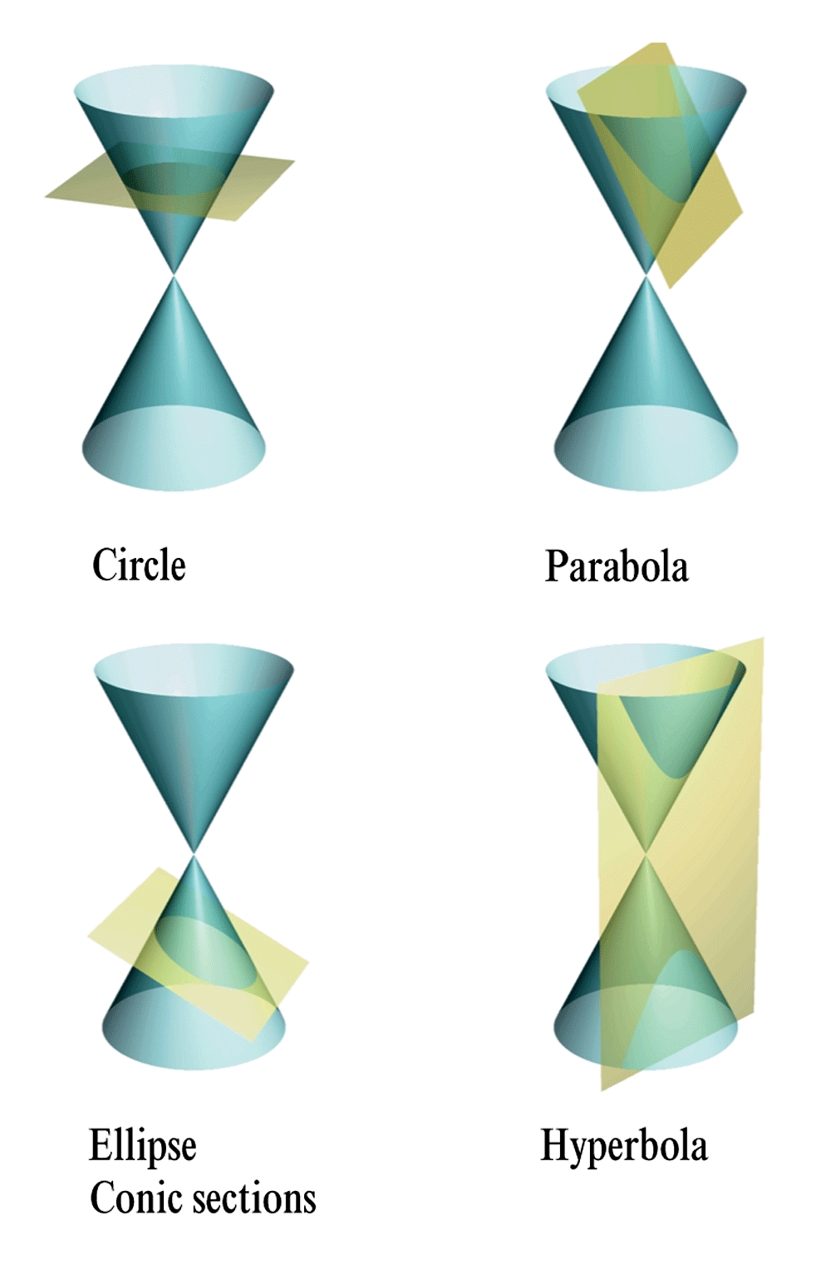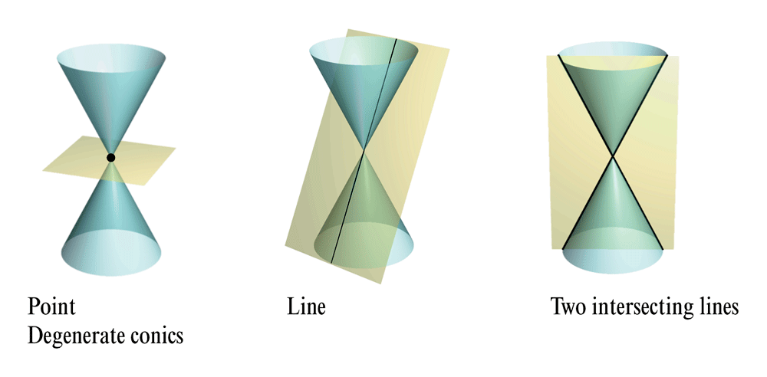

*General Second-degree Equation in Two Variables*



**ellipse:** *Ax*2 + *Cy*2 + *Dx* + *Ey* + *F* = 0, *A* ≠ *C* and *AC* > 0

**circle:** *Ax*2 +*Cy*2 +*Dx*+*Ey*+*F* =0, *A*=*C*

**Hyperbola:** *Ax*2 − *Cy*2 + *Dx* + *Ey* + *F* = 0,

or −*Ax*2 + *Cy*2 + *Dx* + *Ey* + *F* = 0, where *A* and *C* are positive

**Parabola:** *Ax*2 +*Dx*+*Ey*+*F* =0, or *Cy*2 +*Dx*+*Ey*+*F* =0

**Parabolas-*locus of points***

A **parabola** is the set of all points  that are equidistant from a fixed line called a **directrix** and a fixed point called a **focus**, not on the line. The midpoint between the focus and the directrix is the **vertex**, and the line passing through the focus and the vertex is called the **axis** of the parabola. The parabola is symmetric with repsect to its axis. A line segment that passes through the focus of a parabola and has endpoints on the parabola is called a **focal chord**.The specific focal chord perpendicular to the axis of the parabola is the **latus rectum**.

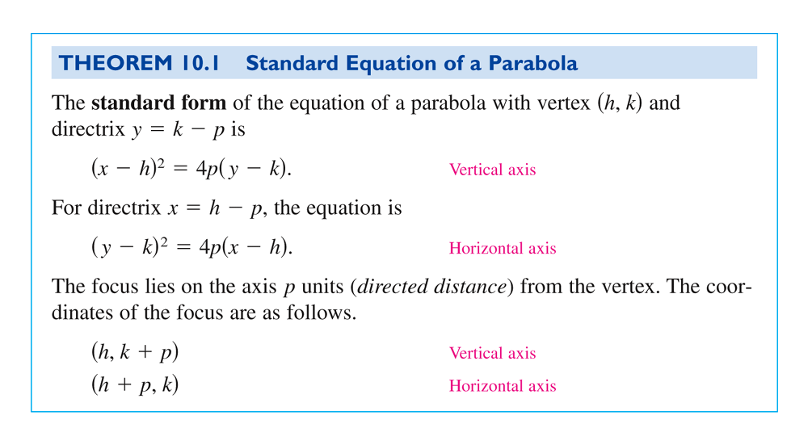

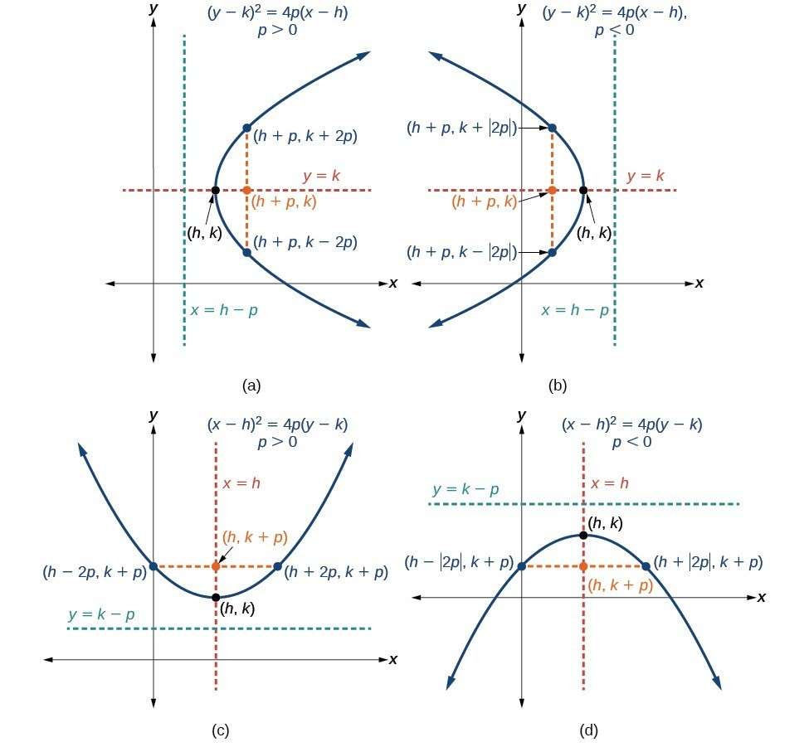

**How to sketch the graph of a parabola centered at (*h*, *k*), given a standard form equation.**

1. Determine which of the standard forms applies to the given equation:

(*y* − *k*)2 = 4*p* (*x* − *h*) or (*x*−*h*)2 =4*p*(*y*−*k*).

2. Use the standard form identified in Step 1 to determine the vertex, axis of symmetry, focus, equation of the directrix, and endpoints of the latus rectum.

1. If the equation is in the form (*y* − *k*)2 = 4*p* (*x* − *h*), then:

-use the given equation to identify *h* and *k* for the vertex, (*h*, *k*)

-use the value of *k* to determine the axis of symmetry, *y* = *k*-set 4*p* equal to the coefficient of (*x* − *h*) in the given equation to solve for *p*. If *p* > 0,

the parabola opens right. If *p* < 0, the parabola opens left.  
-use *h*, *k*, and *p* to find the coordinates of the focus, (*h* + *p*, *k*)  
-use *h* and *p* to find the equation of the directrix, *x* = *h* − *p*-use *h*, *k*, and *p* to find the endpoints of the latus rectum, (*h* + *p*, *k* ± 2*p*)

2. If the equation is in the form (*x* − *h*)2 = 4*p* (*y* − *k*), then:

-use the given equation to identify *h* and *k* for the vertex, (*h*, *k*)

-use the value of *h* to determine the axis of symmetry, *x* = *h*

-set 4*p* equal to the coefficient of (*y* − *k*) in the given equation to solve for *p*. If *p* > 0,

the parabola opens up. If *p* < 0, the parabola opens down.

-use *h*, *k*, and *p* to find the coordinates of the focus, (*h*, *k* + *p*)  
-use *k* and *p* to find the equation of the directrix, *y* = *k* − *p*-use *h*, *k*, and *p* to find the endpoints of the latus rectum, (*h* ± 2*p*, *k* + *p*)

3. Plot the vertex, axis of symmetry, focus, directrix, and latus rectum, and draw a smooth curve to form the parabola.

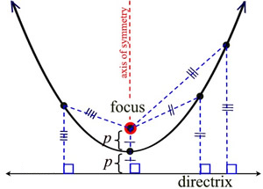 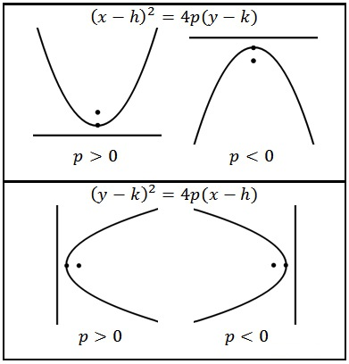

**Ex. 1:** Find the vertex, focus, and directrix of the parabola and sketch its graph.

**Ex. 2:** Find the equation of the parabola with vertex at , and focus at .

**Ex. 3:** Find an equation of the tangent line to the parabola  at . Prove that the *x*-intercept of this tangent line is .

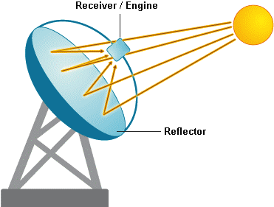 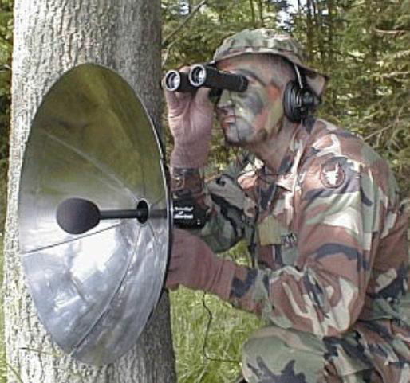

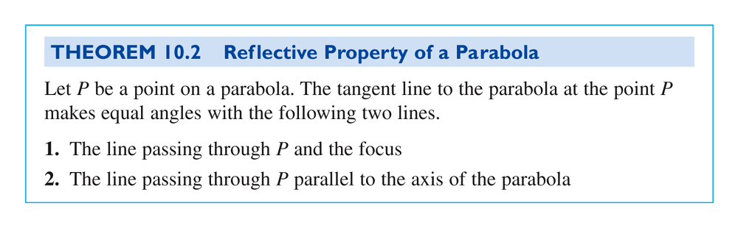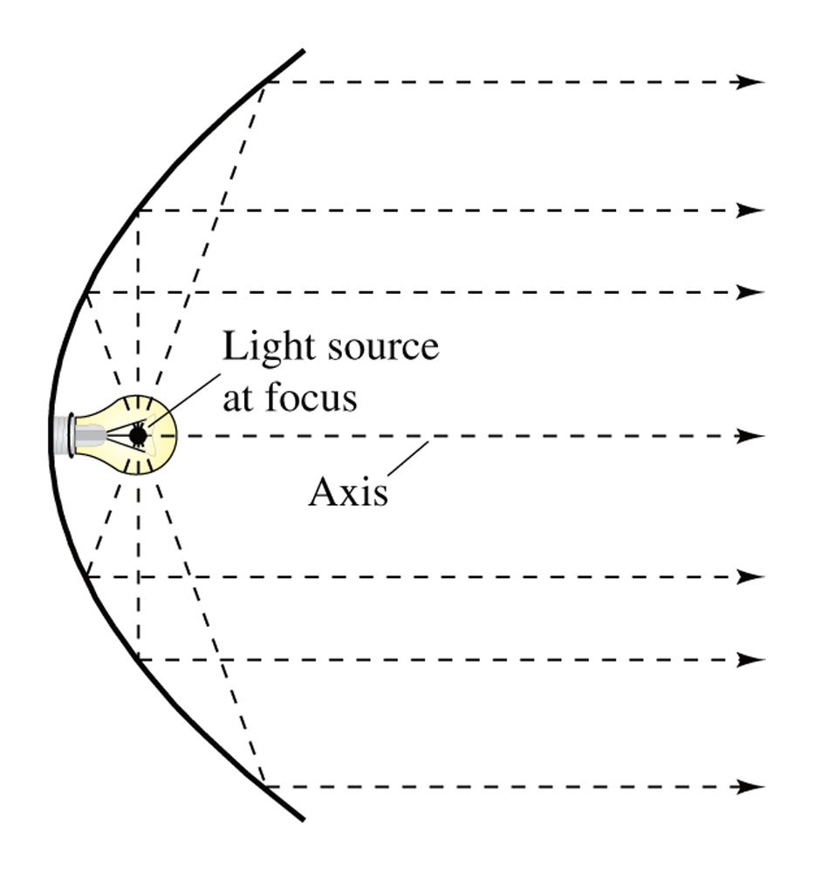 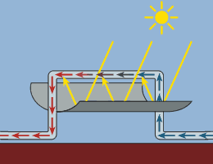 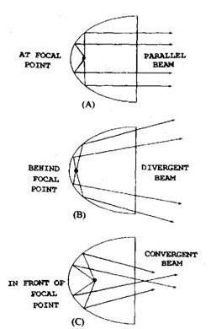

**Ex. 4:** A solar collector for heating water is constructed with a sheet of steel that is formed into the shape of a parabola. The water will flow through a pipe that is located at the focus of the parabola. The parabolic collector is 6 meters wide and 12 meters long, with edges that have been “shaped” to a length of 1 meter. At what distance from the vertex is the pipe? The pipe is in the focus position because of the Reflective Property of a Parabola. The sun’s rays are parallel to the axis of symmetry and at every point they are reflected and “collected” at the focus, heating the water.

**Ellipse-*locus of points***

A **ellipse** is the set of all points  the sum of whose distances from two distinct fixed points called **foci** is constant. The line passing through the foci intersects the ellipse at two points called the **vertices**. The chord joining the vertices is the **major axis**, and its midpoint is the **center** of the elllipse. The chord perpendicular to the major axis at the center is the **minor axis** of the ellipse.

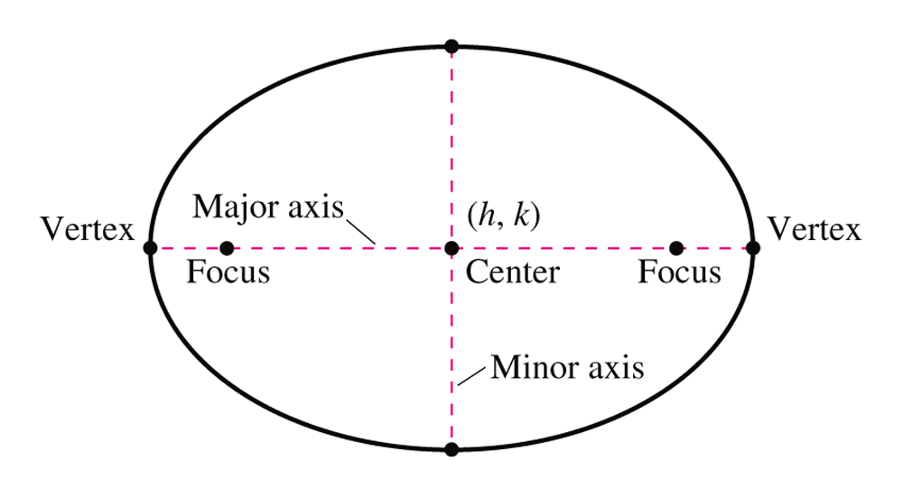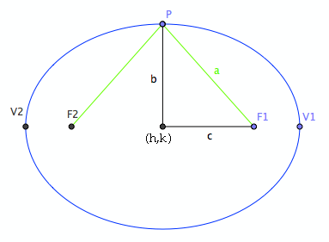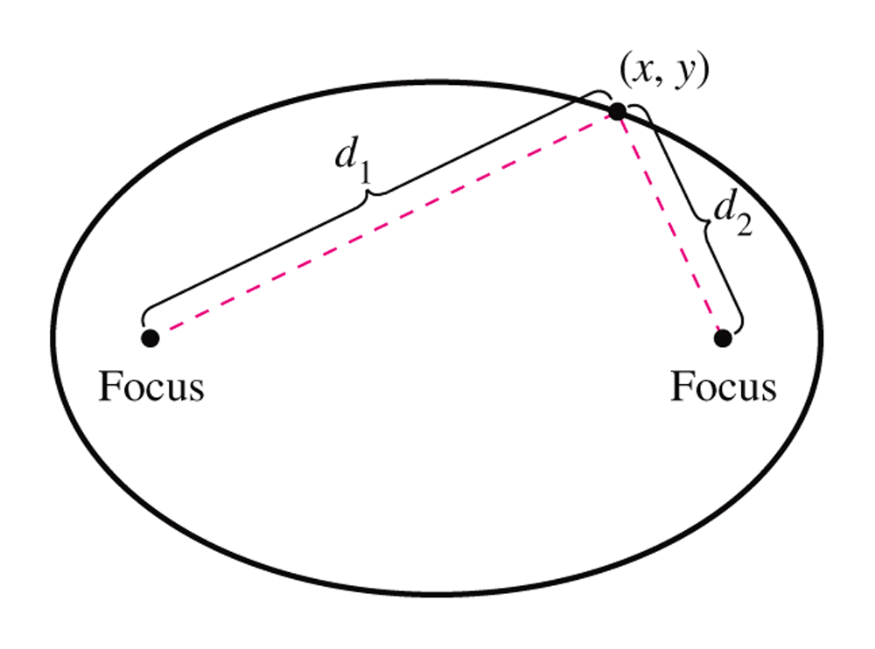

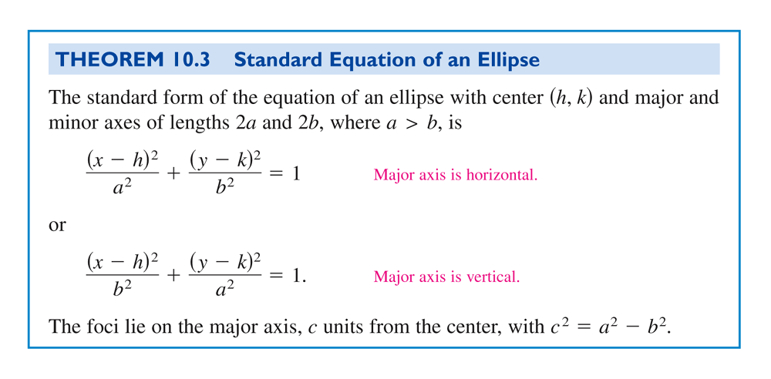

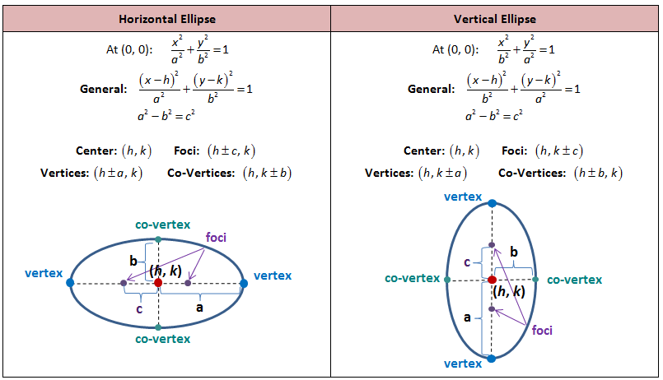

**How to sketch the graph of an ellipse centered at (*h*, *k*), given a standard form equation.**

Use the standard forms of the equations of an ellipse to determine the center, position of the major axis, vertices, co-vertices, and foci.

If the equation is in the form  , where *a* > *b*, then

-the center is (*h*, *k*)  
-the major axis is parallel to the *x*-axis  
-the coordinates of the vertices are (*h* ± *a*, *k*)

-the coordinates of the co-vertices are (*h*, *k* ± *b*)

-the coordinates of the foci are (*h* ± *c*, *k*)

If the equation is in the form  , where *a* > *b*, then

-the center is (*h*, *k*)  
-the major axis is parallel to the *y*-axis  
-the coordinates of the vertices are (*h*, *k* ± *a*)

-the coordinates of the co-vertices are (*h* ± *b*, *k*)

-the coordinates of the foci are (*h*, *k* ± *c*)

Solve for *c* using the equation .

Plot the center, vertices, co-vertices, and foci in the coordinate plane, and draw a smooth curve to form the ellipse.

**Ex. 5:** Write the equation of the ellipse in standard form.Find the center, vertices, foci, and sketch its graph. 

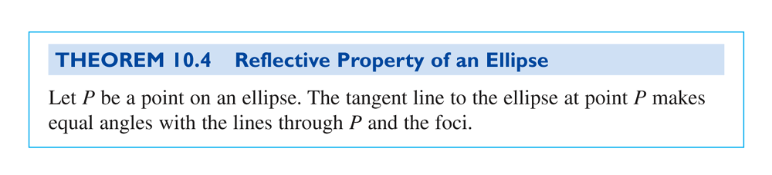

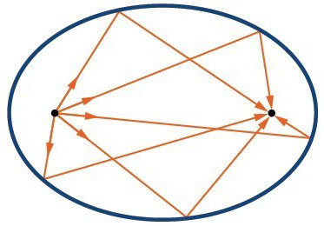 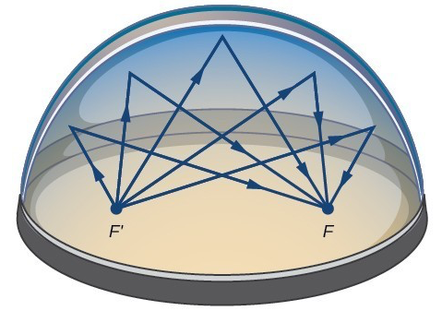

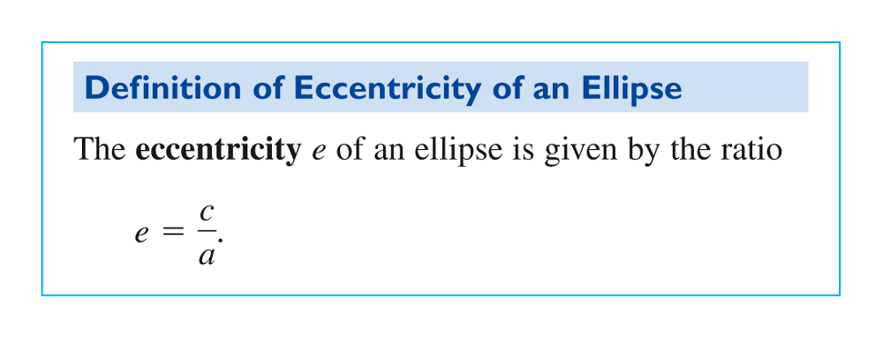

The **eccentricity** of an ellipse is a number that describe the degree of roundness of the ellipse. For any ellipse, 0 ≤ *e* ≤ 1. The smaller the eccentricy, the rounder the ellipse. If *e* = 0, it is a circle and the foci are coincident. If *e* = 1, then the ellipse is a line segment, with foci at the two end points.

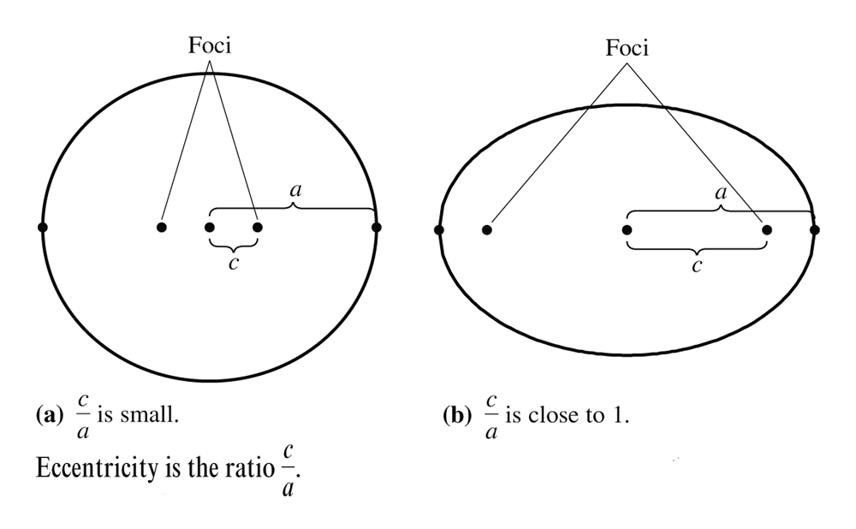

**Ex. 6:** Find the equation of the ellipse if the vertices are  and , and the eccentricity is . Sketch the graph of this ellipse.

**Ex. 7:** Find an equation of the tangent line to the ellipse  at the point . Sketch the graph of the ellipse and the tangent line.

**Hyperbola-*locus of points***

A **Hyperbola** is the set of all points  for which the absolute value of the difference of the distances from two distinct fixed points called **foci** is constant. The line passing through the foci intersects a hyperbola at two points called the **vertices**. The segment connecting the vertices is the **transverse axis**, and the midpoint of the transverse axis is the **center** of the hyperbola. One distinguishing feature of a hyperbola is that the its graph has two serperate *branches*. An important aid in sketching the graph of a hyperbola is the determination of its **asymptotes**. Each hyperbola has two asymptotes that intersect at the center of the hyperbola. The asymptotes pass through the vertices of a rectangle of dimensions  by  , with it center at . The line segment of length  joining  and  is refered to as the **conjugate axis** of the hyperbola.

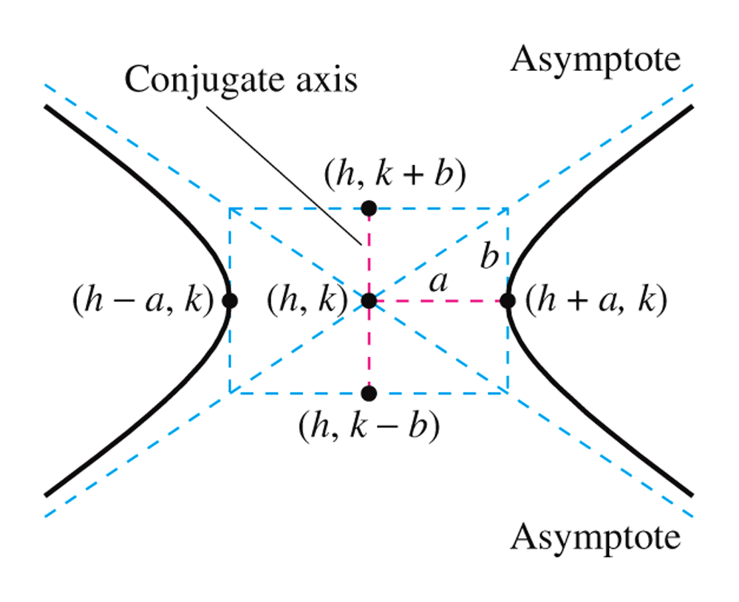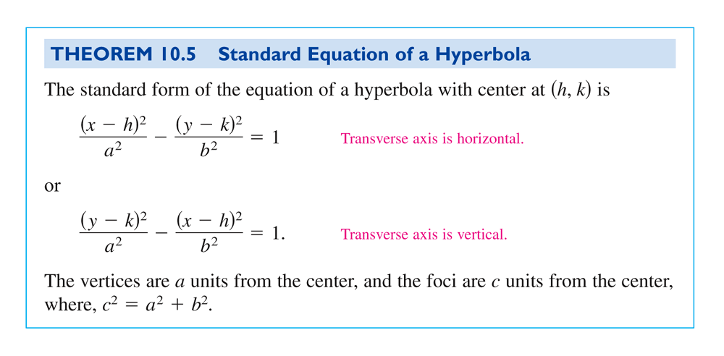

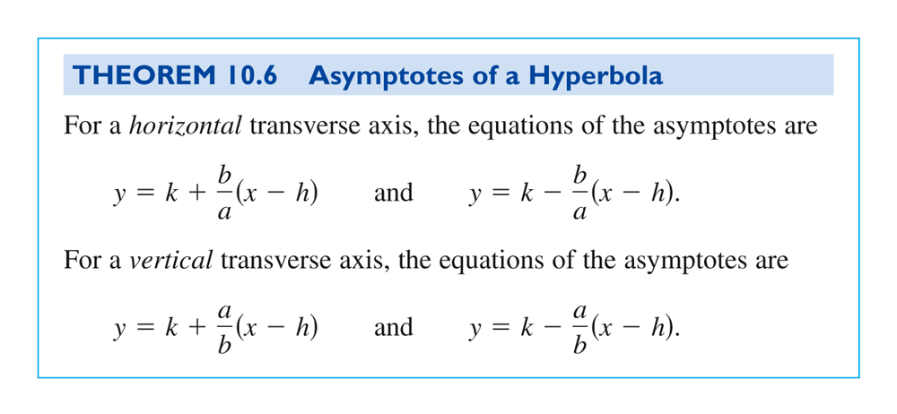

(a)  (b) 

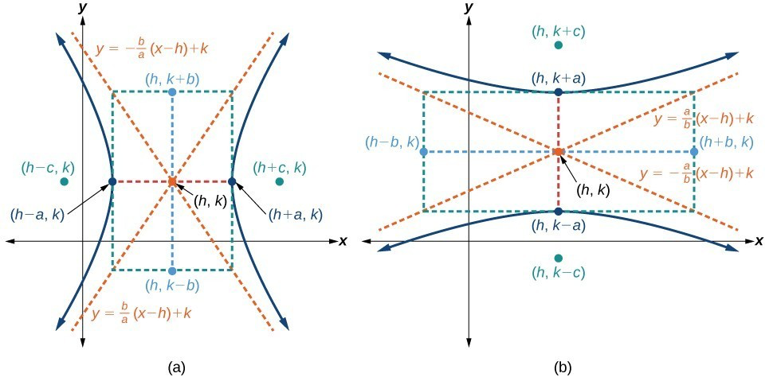

**How to sketch the graph of a hyperbola centered at (*h*, *k*), given a standard form equation.**

Convert the equation to the standard form. Determine which of the standard forms applies to the given equation. Use the standard form to determine the position of the transverse axis; coordinates for the center, vertices, co-vertices, foci; and equations for the asymptotes. Solve for *c* using the equation .

If the equation is in the form , then

-the center is (*h*, *k*)  
-the transverse axis is parallel to the *x*-axis  
-the coordinates of the vertices are (*h* ± *a*, *k*)

-the coordinates of the co-vertices are (*h*, *k* ± *b*)

-the coordinates of the foci are (*h* ± *c*, *k*)

-the equations of the asymptotes are 

If the equation is in the form , then

-the center is (*h*, *k*)  
-the transverse axis is parallel to the *y*-axis  
-the coordinates of the vertices are (*h*, *k* ± *a*)

-the coordinates of the co-vertices are (*h* ± *b*, *k*)

-the coordinates of the foci are (*h*, *k* ± *c*)

-the equations of the asymptotes are 

Plot the center, vertices, co-vertices, foci, and asymptotes in the coordinate plane and draw a smooth curve to form the hyperbola

*Lampshade*

        A household lamp casts hyperbolic shadows on a wall.

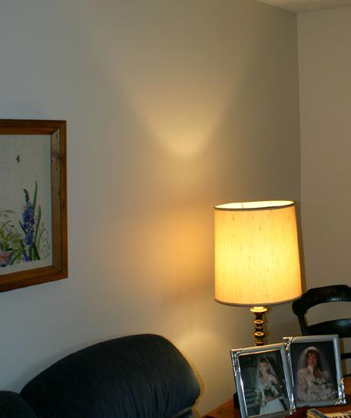

*Gear transmission*

        Two hyperboloids of revolution can provide gear transmission between two skew axes.  The cogs of each gear are a set of generating straight lines.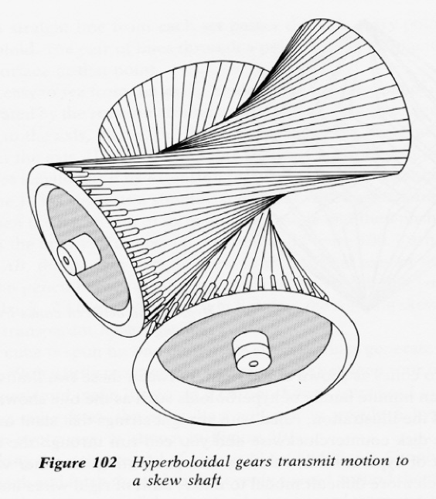

*Sonic Boom*

        In 1953, a pilot flew over an Air Force Base  flying faster than the speed of sound. He damaged every building on the base.

As the plane moves faster than the speed of sound, you get a cone-like wave.  Where the cone intersects the ground, it is a hyperbola.  
The sonic boom hits every point on that curve at the same time. No sound is  heard outside the curve. The hyperbola is known as the "Sonic Boom Curve."

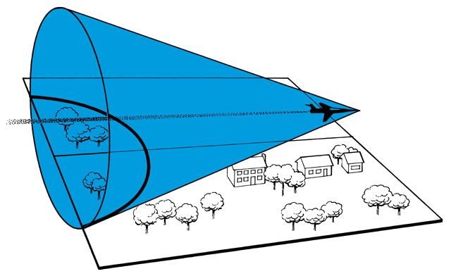

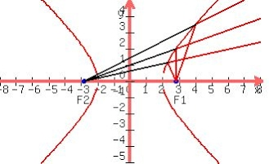 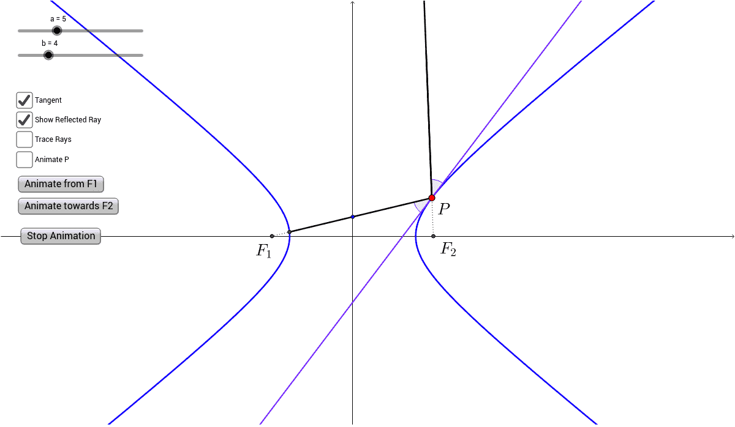

***Reflecting Property of Hyperbolae***

A beam of light is directed at one of the foci (with the the curve "between" the source and the focus) then it will be reflected by the curve through the other focus! If F1 and F2 are the foci of a hyperbola, and P is a point on one of its branches, elementary geometry reveals that the tangent to the curve at P bisects the angle F1-P-F2. The reflecting property then follows from this fact.

This property of the hyperbola has applications! It is used in radio direction finding (since the difference in signals from two towers is constant along hyperbolae), and in the construction of mirrors inside telescopes (to reflect light coming from the parabolic mirror to the eyepiece).

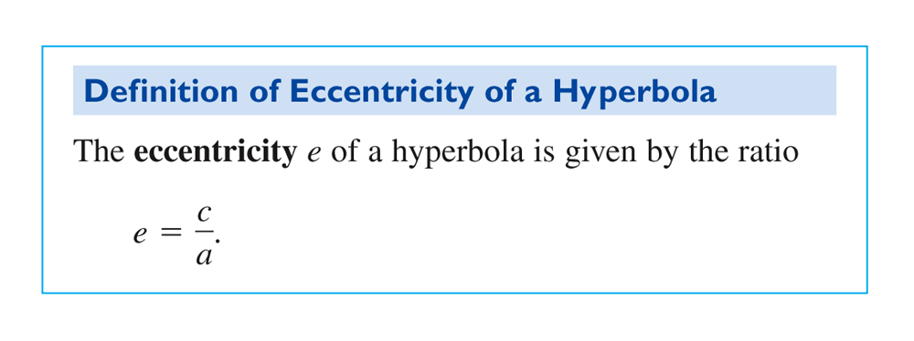

The **eccentricity** of a hyperbola is a number that describes how “narrow,” or how “wide” the branches of the open. For any hyperbola with a smaller eccentricity, we can see the branches will open in a more “narrow” sense. If the eccentricity is larger, then the branches of the hyperbola will open in a “wider” sense.

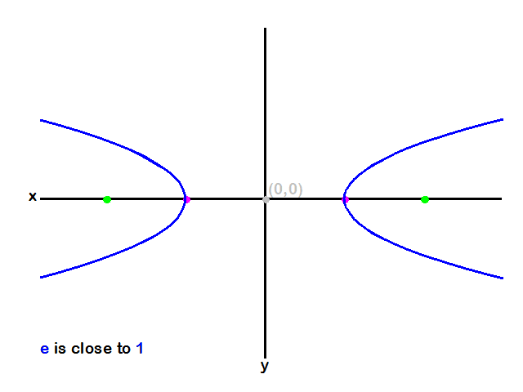 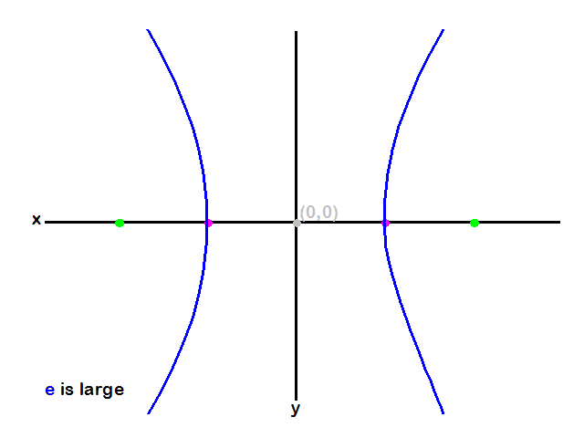

**Ex. 8:** Write the equation of the hyperbola in standard form.Find the center, vertices, foci, and sketch its graph. Find the equations of the asymptotes and sketch the asymptotes. 

**Ex. 9:** Find the equation of the hyperbola in standard form if a focus point is at  and the asymptotes are . Sketch the graph of this hyperbola with its asymptotes.

**Ex. 10:** Find an equations of the tangent lines to the hyperbola  when . Sketch the graph of the hyperbola and the tangent lines.